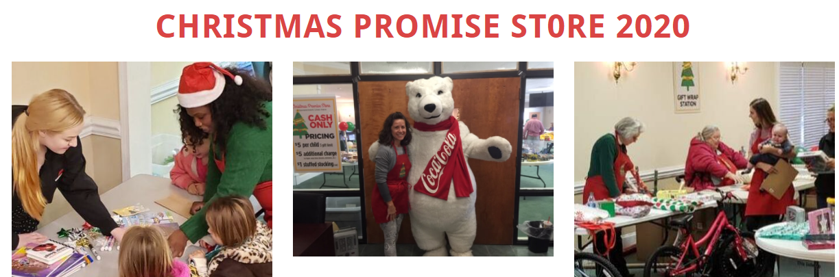
The ​​Christmas Promise Store ​is a program of Family Promise of Hall County. It was birthed in 2018 out of a desire to empower families in our community by providing a Christmas Store where they can shop and purchase gifts for their children at drastically reduced prices. The Christmas Promise Store is funded exclusively by donations. In 2019, 1701 gifts were donated to extend the Christmas Promise Store ministry to 150 families and 468 children in the Hall County area with the help of 111 volunteers.

TOY DONATIONS: ​Donations of new toys ONLY please!
Shop at your favorite store (or find a new gift item from home that you have never opened) and donate to a family with extremely limited financial resources.
Toy donations are needed for students age 0 through 18 years and may be dropped off at Davis Middle School in the Learning Commons.

FOR ANY FAMILY INTERESTED IN SHOPPING AT THE STORE which is open to Hall County Residents only - APPLY NOW (Proof of Hall County residency is required)
Each December, Family Promise of Hall County partners with local businesses, churches and volunteers to host the Christmas Promise Store. We provide a store full of new toys so families may select gifts for their children at drastically reduced prices. $5 per child for 3 gifts. Cash only.
Cada diciembre, Family Promise of Hall County se asocia con negocios locales, iglesias y voluntarios para albergar la tienda Christmas Promise. Ofrecemos una tienda llena de juguetes nuevos para que las familias puedan seleccionar regalos para sus hijos a precios drásticamente reducidos. $5 por niño para 3 regalos.
Register to shop at: https://docs.google.com/forms/d/e/1FAIpQLSf7IKyJo0fvyAj8TaIVMTw4NU1CDWOiUSV657DC6z7CGAB0aw/viewform
VOLUNTEER INFORMATION:
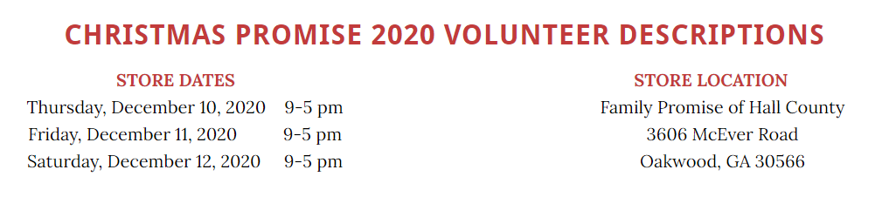
Check out their website for more information: https://www.familypromisehall.org/christmas-promise-store-2020.html

10/01//19

