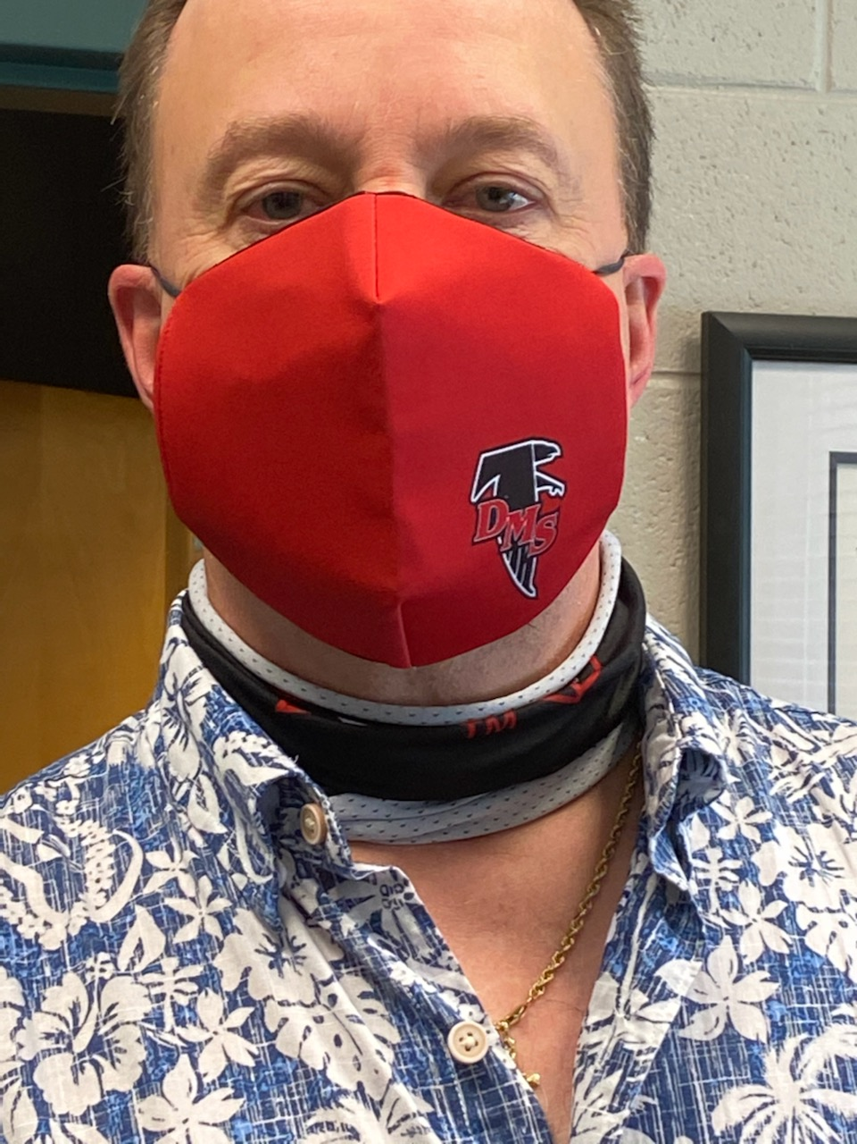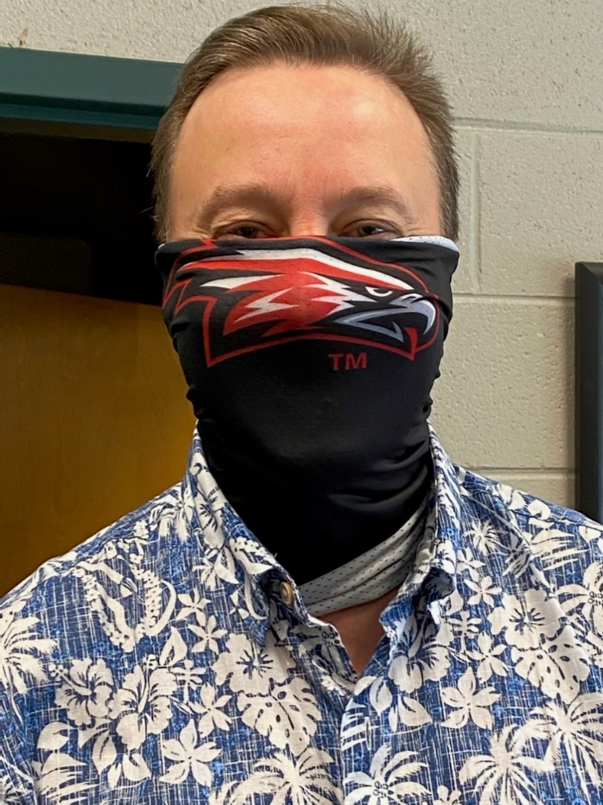

Special Thanks

to our model

Dr. McQueen!

**Limited Availablity at orientation

OR

Pre-Order (Print, complete

this form and return to school

with cash or check.)

**$10 each**

Cash and Checks Accepted. Checks made payable to DMS Athletics. All money due by Friday, August 28th to Mrs. Elzey – Room 175

Total: $______________

Neck Gaiters:

Adult: $10 x ____ = ______

Youth: $10 x ____ = ______

Masks:

Adult: $10 x ____ = ______

Youth: $10 x ____ = ______

***Davis Middle School***

***Masks & Neck Gaiters***

***Support Davis Athletics***